**A**

**REPORT**

**ON**

**“Interface Design”**

**in the**

**Faculty “The Web Development”**

**by**

**Bogdan Zubar**

**PBA in Web Development**

**1 semestr**

**submitted to**

**Trine Falbe Larsen**

Table of content

**Introduction** **3**

User-centered design 3

User-Centered Design Process Map 4

**Problem description** **4**

**Methodology** **5**

Develop a project plan 5

Define the Scope and Stay on Track 5

Identify Target Audiences 5

Set Measurable Objectives 6

Develop design and prototype 7

**Conclusion** **8**

**Sources** **9**

# **Introduction**

Modern approach of design of the interfaces rely on the “User-centered design” method. The main difference from the usual construction of the user flows that, the UCD makes the attention to: Accessibility, Visibility, Legibility, Language.

But “Usable” is not always a user goal. To make a design that you can use comfortable and at the same time get the desired result - you need to adhere to several rules.

## **User-centered design**

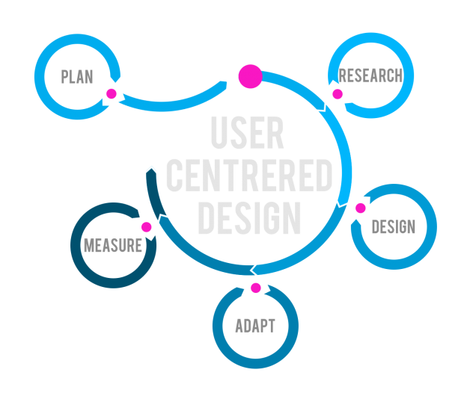

User-Centered Design (UCD) is the process of designing a tool, such as a website’s or application’s user interface, from the perspective of how it will be understood and used by the end user. Rather than requiring users to adapt their attitudes and behaviors in order to learn and use a system, a system can be designed to support its intended users’ existing beliefs, attitudes, and behaviors as they relate to the tasks that the system is being designed to support. The result of employing UCD to a system design is a product that offers a more efficient, satisfying, and user-friendly experience for the user, which is likely to increase sales and customer loyalty.[1](http://www.usabilityfirst.com/about-usability/introduction-to-user-centered-design)

## **User-Centered Design Process Map**

The user-centered design process is composed of several methods and tasks. But what does this process look like? The answer to this question is, of course, it depends. However, on the surface every UX process consists of the same high-level phases. There are four main phases of the user centered design process: Plan, Analyze, Design, Test and Refine. [2](https://www.usability.gov/how-to-and-tools/resources/ucd-map.html)

# **Problem description**

The main idea of my project is combined sources of news in one app. It will allow to get all news from all websites, social networks that client use. There are a lot of different applications in our phones that do the same things and each app require a lot of space in memory. This is a real problem, because even if you don’t use your phone, the application works in the background and use resources, which leads to slow down of response speed. This application may solve all these problems.

# **Methodology**

## Develop a project plan

A project plan takes into account the approach the team will take and helps the team and stakeholders document decisions made regarding the objective, scope, schedule, resources, and deliverables.[3](https://www.usability.gov/how-to-and-tools/methods/develop-plan.html)

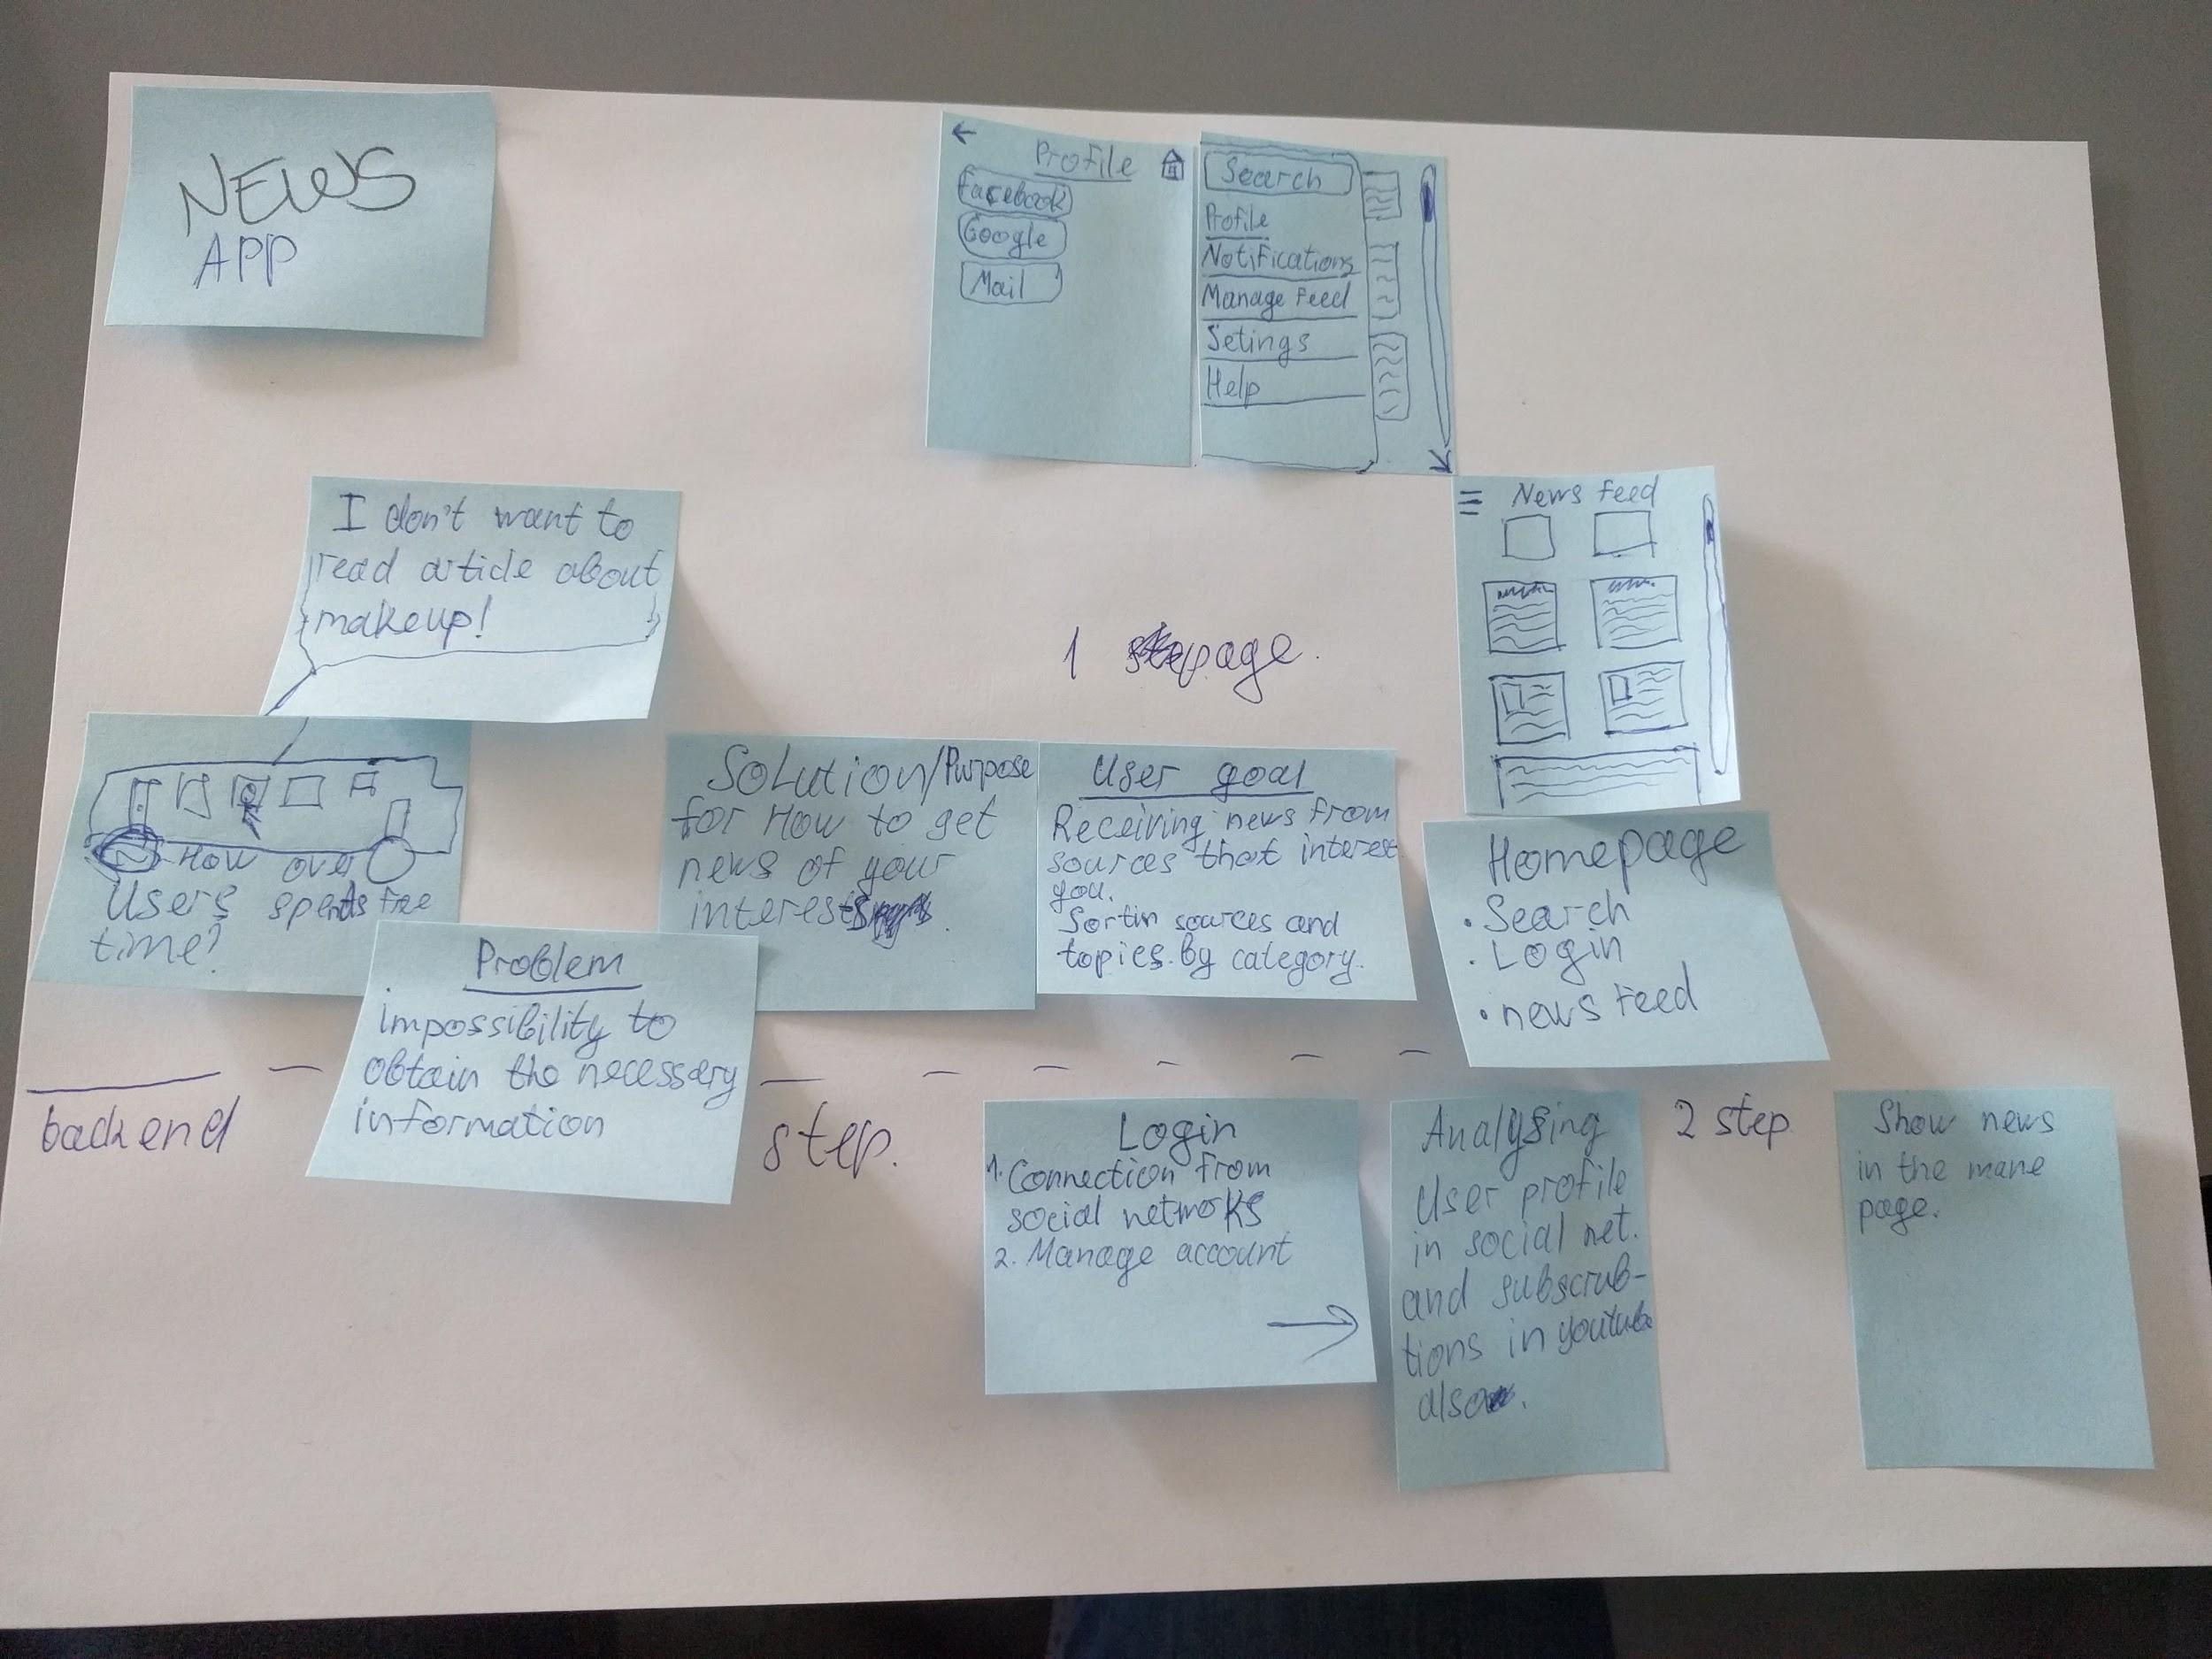

## Define the Scope and Stay on Track

### Identify Target Audiences

At the beginning of the project, it’s vital to think about the audience you are trying to reach, the tasks they come to complete, and how addressing those needs compare to that of your organization. It is important to avoid being broad when defining your target audiences. [3](https://www.usability.gov/how-to-and-tools/methods/develop-plan.html)

To identify and analyze audiences for an existing app, you can gain insight from the app’s analytics, performing market research, and conducting user research methodology. For new app, you may need to rely on market research for initial insight and then refine through conducting additional user research techniques.[3](https://www.usability.gov/how-to-and-tools/methods/develop-plan.html)

The project scope identifies what needs to be accomplished for the project to be considered complete. When discussing scope, it’s important to define:

|  |  |
| --- | --- |
| What product is being developed? | Mobile app |
| What information is going to be covered? Will it feature a particular topic or is it for a particular audience? | The application is intended for all ages regardless of preferences |
| What is the size of the product (i.e. how many pages will the app contain)? | The application is small, consisting of a maximum of 15-20 pages |
| Are you creating an app for an entire agency or organization? Is the app for part of that agency or organization? | The application is a proprietary and independent development |
| What amount of research do you intend to pursue? Is there time built in for incremental adjustments based on those findings. | To develop an application, you need to conduct market analytics, what news sources people use |

For a project to stay on track, it’s important to avoid scope creep. Scope creep refers to when there are things incrementally added the project plan that are individually doable when piled together endanger successful completion of the project as previously defined. Scope creep can be on the business front or the technical front.[3](https://www.usability.gov/how-to-and-tools/methods/develop-plan.html)

### Set Measurable Objectives

Think about your app and define objectives that consider what your organization hopes to achieve. When you set meaningful objectives and set targets to reach, you have the ability to measure success after the app launches.[3](https://www.usability.gov/how-to-and-tools/methods/develop-plan.html)

There are two types of goals/ objectives to consider:

|  |  |
| --- | --- |
| * User goals are users’ task scenarios. They explore what users come to the app to achieve. | Users will be able to receive news from the sources that interest them. The user will receive the news feed according to his wishes. |
| * Usability goals should measure your users’ ability to accomplish tasks on your app. This will tell you whether your app is effective, efficient, and satisfying to your users. | The goal of the user receiving news, to share news with friends, to improve the experience of using news aggregators. |

An example objective, if you want users to get the answers to their own questions without calling your agency or organization, is to reduce phone calls by X amount, saving Y dollars. You can set similar objectives for reducing emails, increasing customer satisfaction, and increasing subscriptions to online newsletters.[3](https://www.usability.gov/how-to-and-tools/methods/develop-plan.html)

## Develop design and prototype

One of the best ways to gain insights in a Design Thinking process is to carry out some form of prototyping. This method involves producing an early, inexpensive, and scaled down version of the product in order to reveal any problems with the current design. Prototyping offers designers the opportunity to bring their ideas to life, test the practicability of the current design, and to potentially investigate how a sample of users think and feel about a product.[4](https://www.interaction-design.org/literature/article/stage-4-in-the-design-thinking-process-prototype)

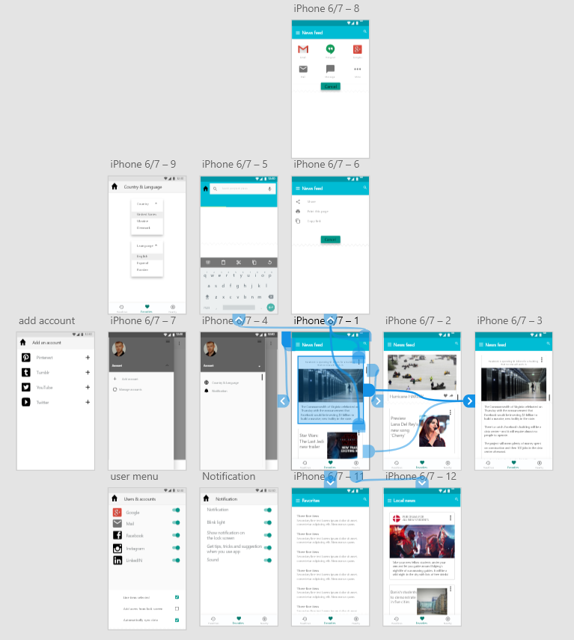

# **Conclusion**

User experience, innovation will become the battleground in almost all consumer businesses within a few years. It has happened widely already within the web page design area, it has happened within the mobile phone area, and it will also happen in industries such as those involving washing machines, stereo and other music systems, remote controls, cars, and so forth. Customers will start to expect and demand reasonable user experiences for any product they purchase.

# **Sources**

1. Definition of User Centered Design

<http://www.usabilityfirst.com/about-usability/introduction-to-user-centered-design> page 3

1. The user-centered design process map <https://www.usability.gov/how-to-and-tools/resources/ucd-map.html> page 4
2. Develop a project plan

<https://www.usability.gov/how-to-and-tools/methods/develop-plan.html> page 5-7

1. Develop design and prototype

<https://www.interaction-design.org/literature/article/stage-4-in-the-design-thinking-process-prototype> page 7